**Lab No.5**

01. You must have seen the question before deleting anything like “Are you sure to delete [Y/y] / [N/n] ? Create a program that asks for this question if user enters Y or y it prints “Deleted successfully”. If the user enters N or n it prints “Delete cancelled” otherwise it prints choose the right option using switch statement.

#include <stdio.h>

#include <stdlib.h>

int main() {

char user_input;

printf("Are you sure to delete [Y/y] / [N/n]? ");

scanf(" %c", &user_input);

switch (user_input) {

case 'Y':

case 'y':

printf("Deleted successfully\n");

break;

case 'N':

case 'n':

printf("Delete cancelled\n");

break;

default:

printf("Choose the right option\n");

}

return 0;

}

**Out put:**

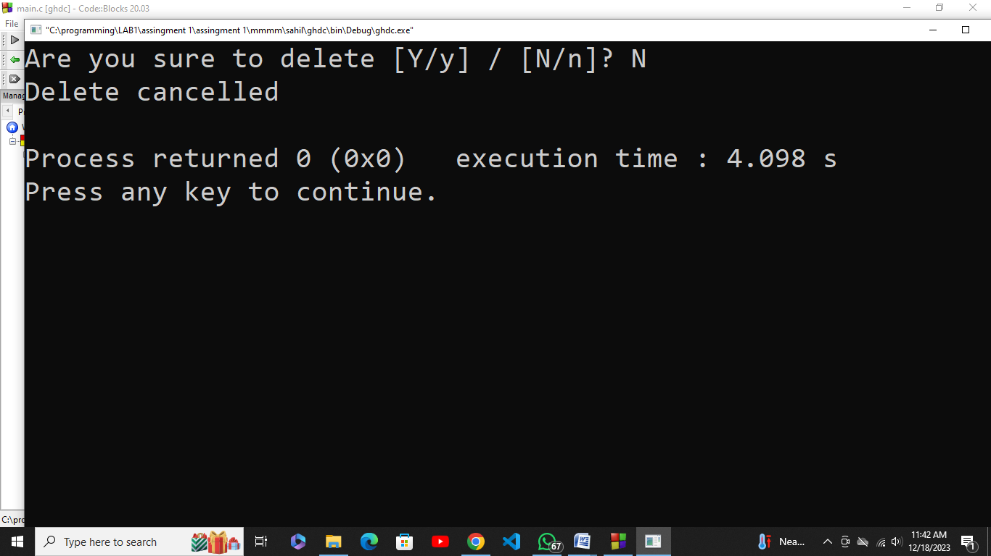

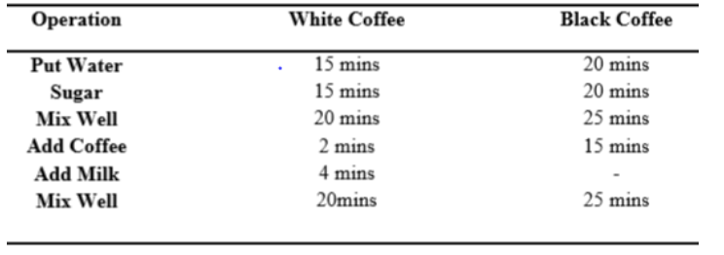02. Write a program to control a coffee machine. Allow the user to input the type of coffee as B for Black and W for White. Ask the user if the cup size is double and if the coffee is manual. The following table details the time chart for the machine for each coffee type. Display a statement for each step. If the coffee size is double, increase the baking time by 50 percent. Use functions to display instructions to the user and to compute the coffee time

.

#include <stdio.h>

#include <stdlib.h>

// Function to display instructions for the user

void displayInstructions(char coffeeType, char isDouble, char isManual) {

printf("Coffee Machine Instructions:\n");

printf("1. Place the cup.\n"); **Out put:**

printf("2. Add coffee grounds.\n");

double brewingTime = 5.0;

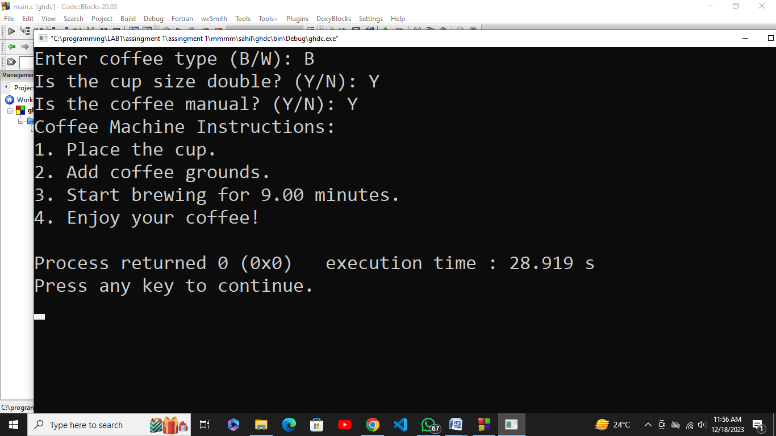

if (isDouble == 'Y' || isDouble == 'y') {

brewingTime *= 1.5;

}

if (isManual == 'Y' || isManual == 'y') {

brewingTime *= 1.2;

}

if (coffeeType == 'W' || coffeeType == 'w') {

brewingTime += 2.0;

}

printf("3. Start brewing for %.2f minutes.\n", brewingTime);

}

int main() {

char coffeeType, isDouble, isManual;

printf("Enter coffee type (B/W): ");

scanf(" %c", &coffeeType);

printf("Is the cup size double? (Y/N): ");

scanf(" %c", &isDouble);

printf("Is the coffee manual? (Y/N): ");

scanf(" %c", &isManual);

displayInstructions(coffeeType, isDouble, isManual);

printf("4. Enjoy your coffee!\n");

return 0;

}

03.Write a program in which user enters his NTS and F.Sc marks and your program will help student in selection of university. Based on these marks Student will be allocated a seat at different department of different university.

#include <stdio.h>

#include <stdlib.h>

int main() {

int ntsMarks, fscMarks;

printf("Enter NTS marks: ");

scanf("%d", &ntsMarks);

printf("Enter F.Sc marks: ");

scanf("%d", &fscMarks);

if (ntsMarks >= 70 && fscMarks >= 80) {

printf("Congratulations! You are eligible for Computer Science at FAST-NUCES.\n");

} else if (ntsMarks >= 60 && fscMarks >= 70) {

printf("Congratulations! You are eligible for Electrical Engineering at UET.\n");

} else if (ntsMarks >= 50 && fscMarks >= 60) {

printf("Congratulations! You are eligible for Business Administration at LUMS.\n");

} else {

printf("Sorry, you did not meet the eligibility criteria for any university.\n");

}

return 0;

}

**Out put:**

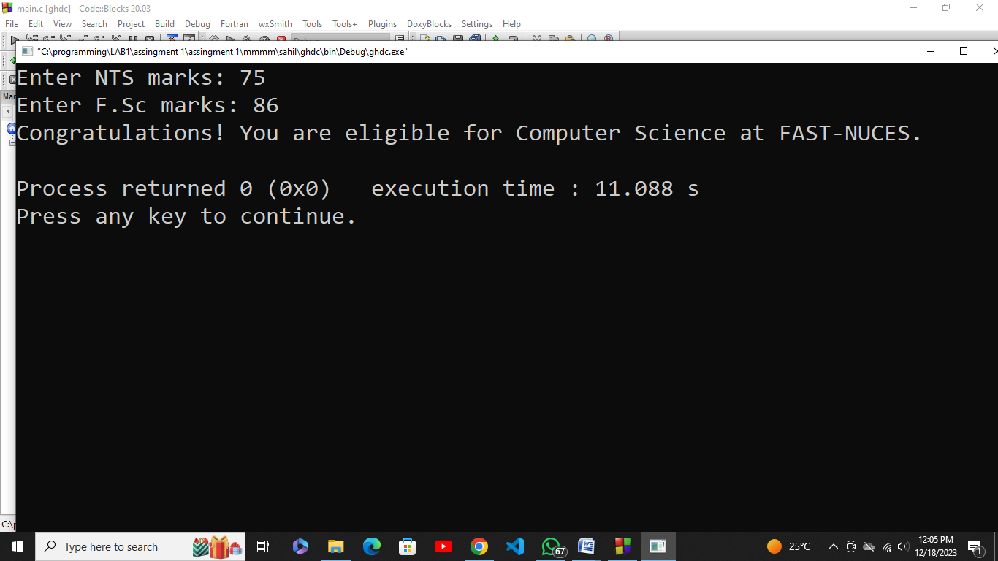

04. Using IF and Switch statement, write a program that displays the following menu for the food items available to take order from the customer:

B= Burger (Rs. 200), F= French Fries (Rs. 50)

P= Pizza (Rs. 500), S= Sandwiches (Rs. 150)

The costumer can order any combination of available food. The program first ask to enter the no of types of snacks i.e. 2, 3 or 4 then it ask to enter the choice i.e. B for Burger and then for quantity. The program should finally display the total charges for the order.

#include <stdio.h>

#include <stdlib.h>

int main() {

char choice;

int quantity, numTypes;

double totalCharges = 0.0;

printf("Menu:\n");

printf("B= Burger\t(Rs. 200)\n");

printf("F= French Fries\t(Rs. 50)\n");

printf("P= Pizza\t(Rs. 500)\n");

printf("S= Sandwiches\t(Rs. 150)\n");

printf("Enter the number of types of snacks (2, 3, or 4): ");

scanf("%d", &numTypes);

for (int i = 1; i <= numTypes; i++) {

printf("Enter choice for snack %d (B/F/P/S): ", i);

scanf(" %c", &choice);

printf("Enter quantity for snack %d: ", i);

scanf("%d", &quantity);

switch (choice) { **Out put:**

case 'B':

case 'b':

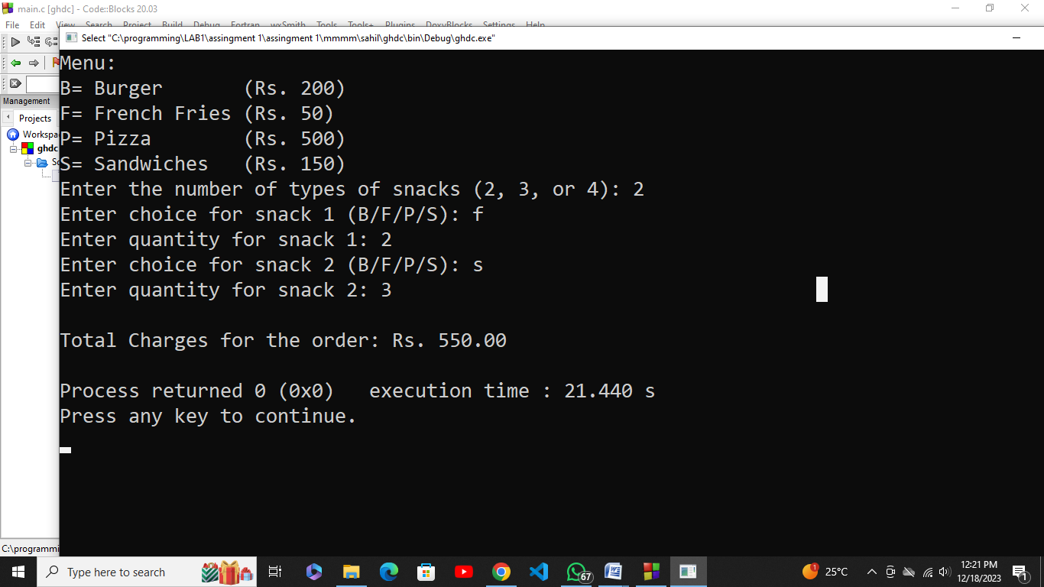

totalCharges += quantity * 200.0;

break;

case 'F':

case 'f':

totalCharges += quantity * 50.0;

break;

case 'P':

case 'p':

totalCharges += quantity * 500.0;

break;

case 'S':

case 's':

totalCharges += quantity * 150.0;

break;

default:

printf("Invalid choice. Please enter B, F, P, or S.\n");

i--;

}

}

printf("\nTotal Charges for the order: Rs. %.2f\n", totalCharges);

return 0;

}